

Our end-to-end rostering: just a few sample screens in narrative style…

First, a diagram puts your rostering process and our rostering modules on the same page.

Your greenfield roster
The ideal roster you would put in place were you to start from scratch. Most organisations never actually achieve this ideal.

Your core roster
The planned roster that as at June is your best estimate of the roster that you will run in the coming financial year.

Your posted roster
The planned roster that as at the start of the pay period is your best estimate of the roster that you will run in the coming pay period.

Your worked roster
The posted roster, except with unplanned variations (for example, sick leave, swapped shifts … ) included.
RosterCoster.xls
This high tech and robust Excel-based layout is very convenient for planned rosters (greenfield, core and posted). Then, the instant a posted roster is signed off by the manager, it is uploaded to the web (RosterCoster.com), which can micro-manage staff availability and shift replacement much better than any Excel-based system.
RosterCoster.com
Staff availability and shift replacement should, we recommend, be done online. Anybody who has ever done this on paper, or in Excel or Word, will probably well know how complicated planned rosters can look by the end of the fortnight, if not done online. Colour coding everywhere, the initials of casuals sketched in all over the place, arrows and comments everywhere…
Roster Review Resource (RRR)
A virtual exercise that takes your organisation back to a “green field”, with no staff hired yet. An assessment of your rostering needs creates an ideal (greenfield) roster that is a benchmark for your core, posted and worked rosters. N.b. if you are actually in a greenfield situation, then the exercise is not virtual. Rather, it is likely to be part of a tender process.
Now, let’s assume you want to engage us. We start with an assessment of your needs, using our Roster Review Resource (RRR)

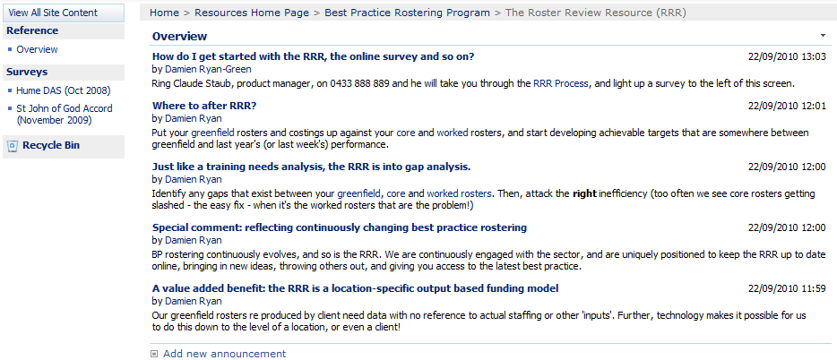
Here is a sample of the sorts of online questions we ask…

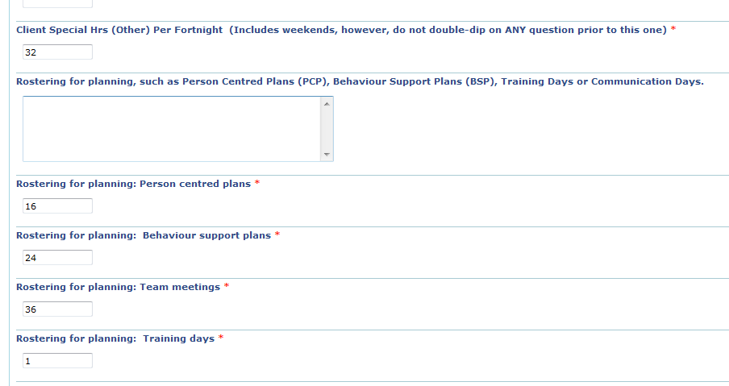
Our software then proposes an ideal (“greenfield”) roster …

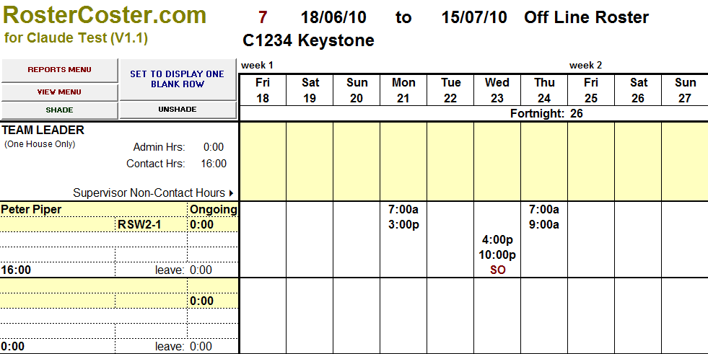
For the sake of the exercise, let’s imagine you actually use the ideal. It ends up online like this…

This is how it looks to your only staff member, Peter Piper, who has logged in using his iPhone. Notice that Peter has added some info of his own: he is available for extra hours on Saturday, but not on Sunday…

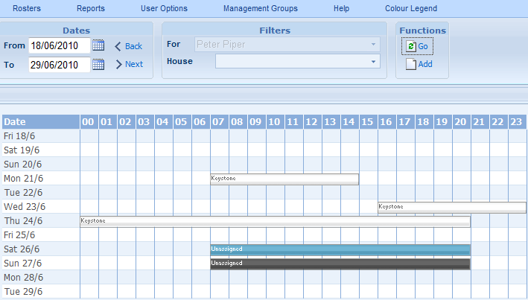
A manager then logs in and can see multiple staff, including Peter:

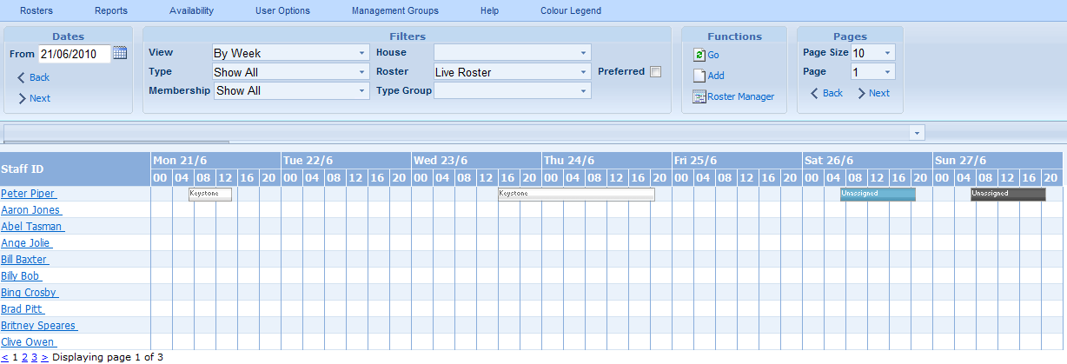
The manager says “why not, let’s give Peter a shift on Saturday”…

Unfortunately Peter is into overtime, and the shift displays quite garishly!

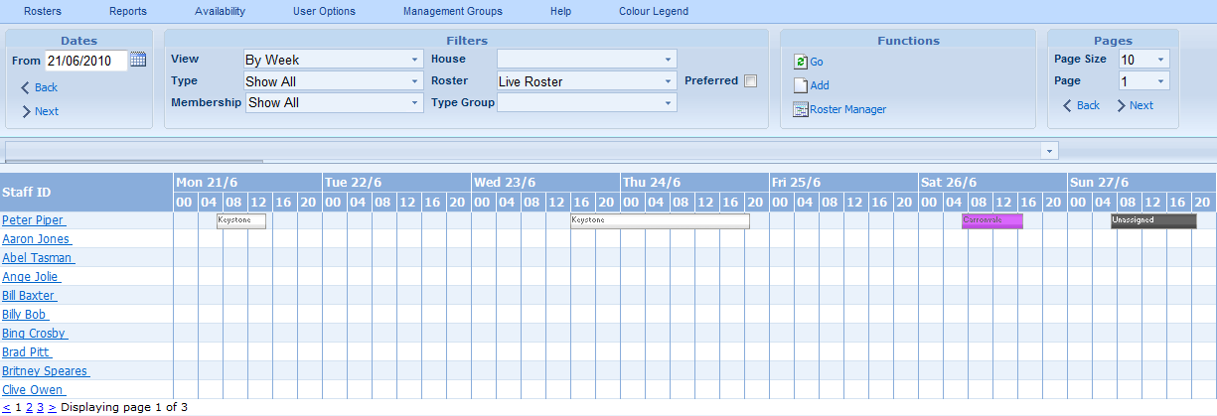
Then, at any time during the year, the manager can compare the cost of the overall worked roster against the annual cost prediction arising from the original ideal (“greenfield”) roster, which would have looked something like this…
…based, as the costing would be, on certain assumptions about the habits of the house…

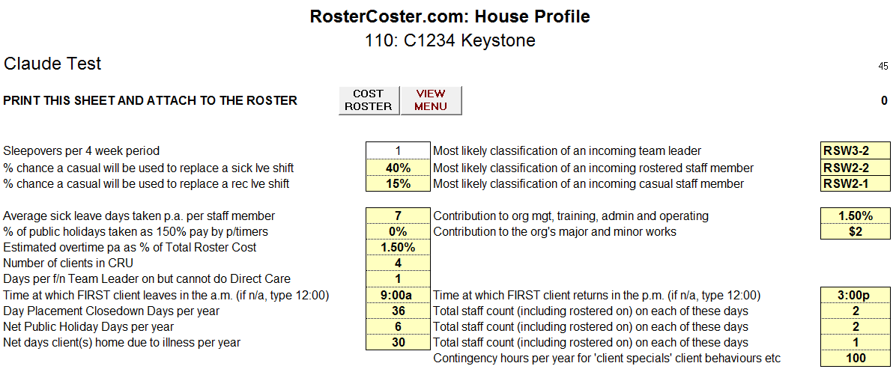

Thank you for reading our rostering scenario. We will leave you with a typical (sample) data flow, should you opt to have your payroll system outsource the rostering function to us.

Platform: your payroll system |  | Platform: EMSOnline |  | Platform: RosterCoster.com
App: processing of staff pays |  | App: RosterCoster.xls |  | App: Availability & shift replacement
 |  | > Includes our benchmark costing tool for annual predictions of a core "planned" roster cost, which can be compared via tailored reports (see below) with "worked shifts". |  | > Includes an Award builder to allow shifts to be costed for comparison with the core roster costing and other purposes.
 |  | > Includes our benchmark costing tool for annual predictions of a core "planned" roster cost, which can be compared via tailored reports (see below) with "worked shifts". |  | > Includes an Award builder to allow shifts to be costed for comparison with the core roster costing and other purposes.
 | Staff details | > Security provided by your own firewall. | Planned rosters | > Security provided by us.
> Staff details table | Worked shifts | > Good platform for drafting and preparing "planned rosters" (core rosters at start of year, and posted every 4 weeks). Cover as many shifts and planned leave at this level as you can, to minimise the "unplanned" staff replacement you will need to deal with in the online platform, see right. | Worked shifts | > Right platform for "worked rosters". Users can log shift preferences online "at work or home", and the org can shift-replace online, with no limit to the number of alterations made to each shift.
> Accepts a .csv file each fortnight from RosterCoster.com. |  | > Ongoing tailoring of reports quick and inexpensive to create, allowing you to "have" a range of tailored reports that you could not justify having coded online for your specific org. |  | > Contains basic reports, and you can have additional reports created in this platform. However, recommend that it is more cost effective to create most tailored reports in the less-expensive-to-manipulate EMSOnline (see left).
 |  | > Future opportunity to load other apps at EMSOnline, for example, your own "standalone" templates in MS Excel and MS Word decommisioned in favour of networked versions with same look and feel.

