

System: Residential Statement App @ EMSOnline
FAQ – How do I print my Residential Statement?
Visit EMSOnline, visit the Residential Statement App, then select a client in the Residential Statement form. (Check the client’s statement to make sure it’s up to date and press ‘Save this record” near the bottom of the screen)
Select ‘Print Statement’ at the top of the data entry form as shown below
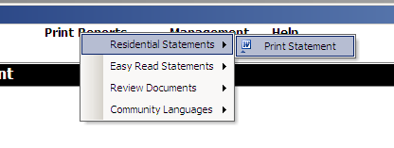
Say ‘yes’ to the following message:
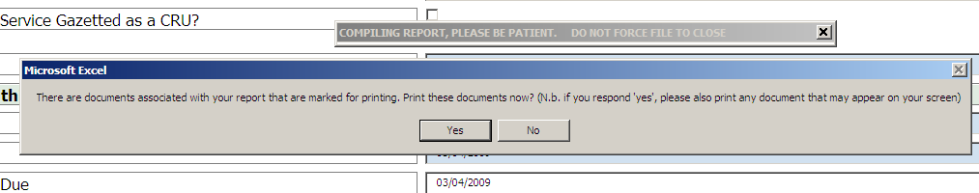

Now here is the important bit: if you want to print in a way that is “not default” (for example, in colour, or to a different printer), then you need to respond “Yes” to the following question (otherwise, respond “No”, and you can ignore the remaining comments below):
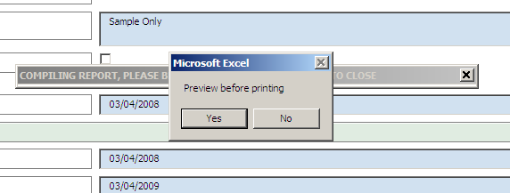

Note the following “useful comment” that pops up:
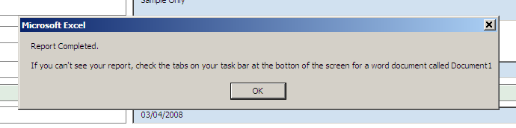

Then, visit that Word document called “Document 1” and select “File / print”, and, if necessary, for example to print in colour, Properties”, as shown below:
