

System: Online rostering at www.RosterCoster.com
How do I add a new staff member into RosterCoster? (N.b. you need to have certain permissions to do this.)
First, without actually doing anything, let’s just have a look at the screens we will be using. Visit www.RosterCoster.com and login at the top right hand corner. Then, click Management Groups > Staff List to bring up the GENERAL PERMISSIONS SCREEN (see below).
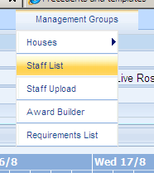 |  | 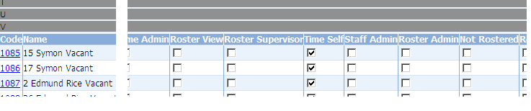

Next, have a look at a staff member’s HOUSE BY HOUSE PERMISSIONS SCREEN (see below).
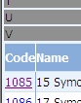 |  | 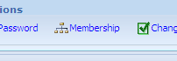 |  | 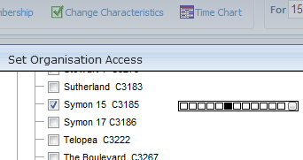

OK … let’s go. But one very handy tip before we start: If you add a new staff member, and don’t immediately give that person membership to your organisation, you will kill your own access to that person (in which case, email RosterCoster@gmail.com and we’ll bring him or her back for you.)
STEP 1: ADD A NEW STAFF MEMBER
Press ‘Staff List’ the ‘Add’:

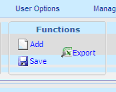
Fill in at least the amount of information below.
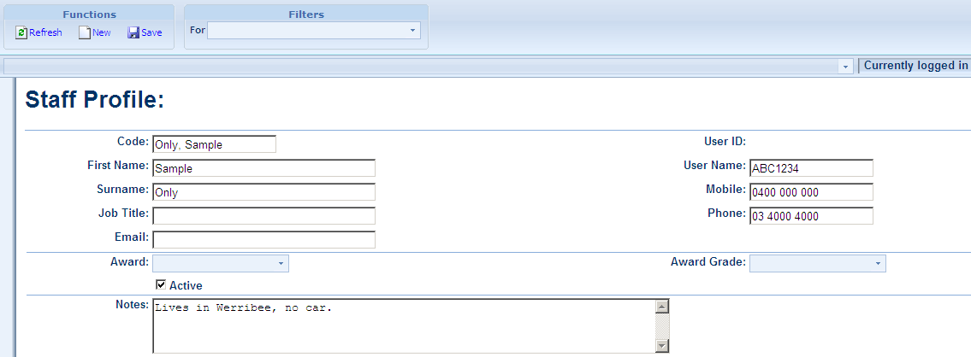
Then press ‘Save’ near the top of the screen.
Then … immediately, before you forget, give that person ‘Membership’ to your organisation, and give that person a password, using the two links below (which appeared as soon as you pressed ‘Save’):
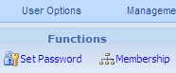
Please now go to the next page for some handy tips when giving people ‘Membership’ to your organisation.
Click this:
To bring up this:
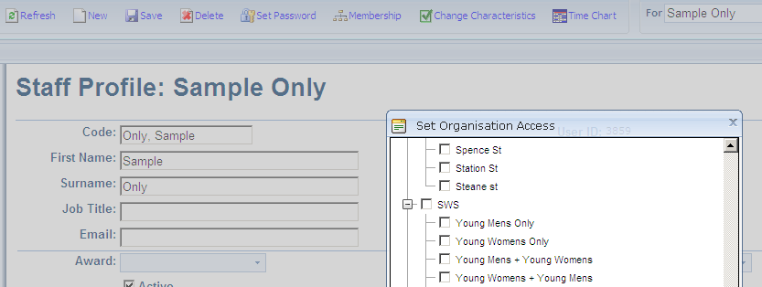
Put a tick in every unit or house that the manager or staff member will be allowed to work in or ‘see’. For example, in the example above, the manager of organisation ‘SWS’ would have the left hand side ticked, but a staff member that works in ‘Young Mens Unit’ but is not allowed to work in ‘Young Women’s Unit’ would have the right hand side ticked:
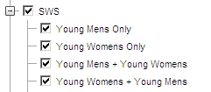 | 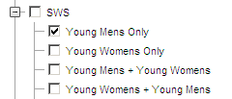

Now, don’t forget to scroll down and press ‘OK’! (this saves the above ticks…)
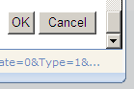
OK. It is safe to visit other screens now: this person will not disappear from your screens when you next visit RosterCoster, because he or she now exists in at least one location in your organisation.
Now that the staff member exists, you need to give hom permissions to ‘do things’ like ‘log availability’.
Revisit the main ‘Staff List’ screen, the one that you started off in
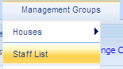
You will notice that he has a little red exclamation mark next to his name, just to warn you that there are no permissions ‘ticks’ next to his name (yet!) either in this screen or any other screen.
Let’s assume the person does not fill shifts. Put a ‘tick’ against the column ‘Time Self’, as shown below.
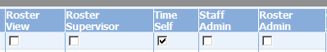
OK, that’s it. Done!
OK. Time now to see the various types of permissions a person can have.
Because a manager fills shifts but does not do them, and a casual does shifts but does not fill them.
A supervisor, on the other hand, fills shifts AND does them!
STEP 2: HOW TO USE THE GENERAL PERMISSIONS SCREEN
Also known as the ‘Staff List’ screen:
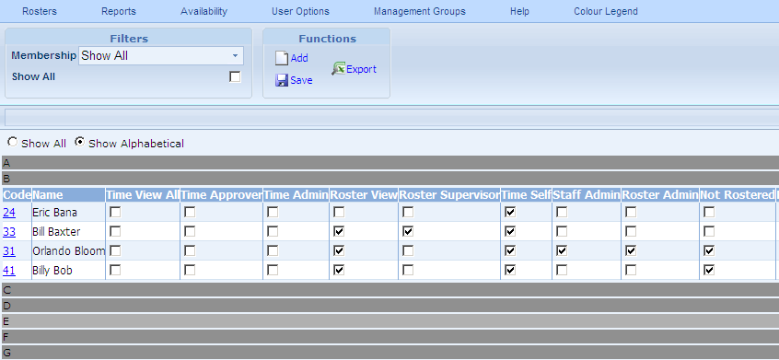
In the example above:
- Eric Bana is a staff member who does extra hours or casual shifts, but does not replace shifts. That is, the only thing he can do is log his availability.
- Bill Baxter is a supervisor, or a staff member who is allowed to replace shifts. Bill ALSO does extra hours himself, from time to time.
- Orlando Bloom is a manager (or he might be ‘admin’). He does NOT do shifts (‘Not Rostered’). He can, however, control staff permissions (‘Staff Admin’), and he can replace shifts (‘Roster Admin’).
- Billy Bob is a CEO or a Finance Manager who does not do shifts, and does not control staff permissions. But he does like to get in from time to time just to have a look (‘Roster View’).
By the way, there is a hierarchy built into the software. If Orlando locks a shift, neither Bill nor Eric can change it. And if Bill locks a shift, Eric can’t change it.
HOW TO USE THE HOUSE BY HOUSE PERMISSIONS SCREEN
I clicked on Bill Baxter’s ID number (it was 33; see previous page), then hit the link called …
And this is what I saw:
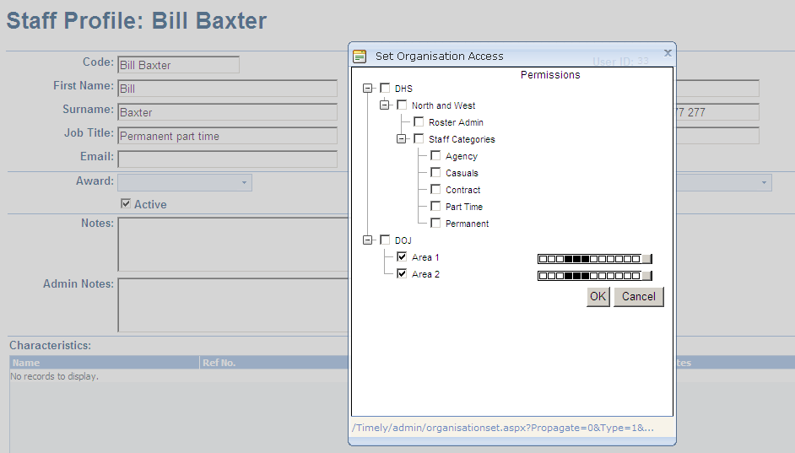
Yes, Bill Baxter has access to two work sites, namely, ‘Area 1’ and ‘Area 2’. By default, he has three levels of permission (see the three little black boxes), and these match exactly the ticks in his GENERAL PERMISSIONS SCREEN (see previous page). But here’s the thing:
- Bill is a regular staff member permitted to fill shifts in ‘Area 1’; BUT…
- In ‘Area 2’, I want Bill to pick up extra shifts here and there, but to NOT be allowed to fill shifts.
OK, here’s what you do: first, click on the tiny little grey box for ‘Area 2’ as shown below:
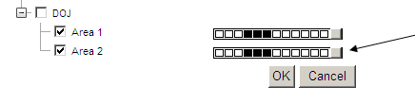

This brings up the HOUSE BY HOUSE PERMISSIONS SCREEN as follows:
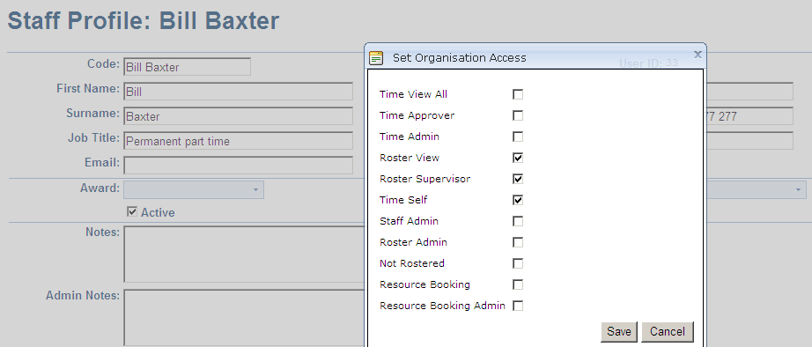
Untick ‘Roster View’ and ‘Roster Supervisor’ like this below, then press ‘Save
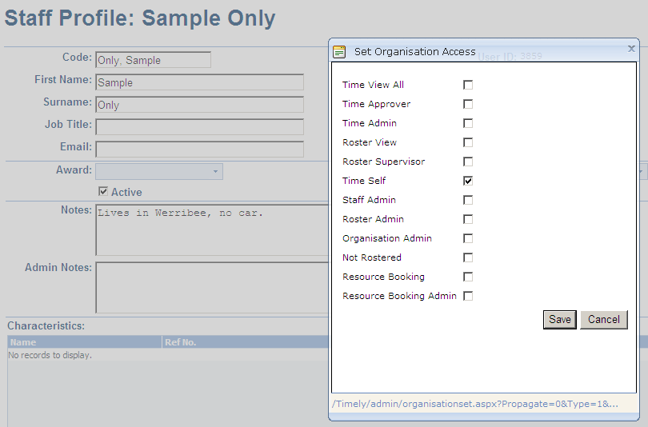
And that’s it: all done.

